Experiment No. 7 and 8
DESIGN AND HARDWARE VERIFICATION OF A SEVEN SEGMENT DECODER
Garrett Foster
Department of Electrical and Computer Engineering
University of Missouri – Rolla
gdfcp2@umr.edu

Computer Engineering 112 Section 3D
Group Member: Joe Welch
April 11, 2006
Abstract:
The purpose of the first part of this lab is to develop experience with Karnaugh maps and seven segement displays. It also gives us experience designing with the Xilink field programmable gate arrays. The second part of this lab is used to verify that the hardware realization of our second segement decoder performs as predicted by our logic simulation.

Table of Contents

Abstract 2

Introduction 4

Background of the Seven segment decoder 5

Procedure, results, and analysis 8

Conclusions 9

Appendix A 10

Appendix B 11

Appendix C 11

References 12

Introduction:
The goal of this lab is to implement logic functions to utilize a 7 segment display. To implement these logic functions they must first be created in Design Architect (DA) and then checked with QuickSim (QS). Once the logic functions have been verified in QS you can build the logic circuit and then test its output.

Background of the Seven segment decoder:
The seven segment decoder as explained in the lab manual has many different uses; one example is a digital watch. The seven segment display is shown below in figure 1.
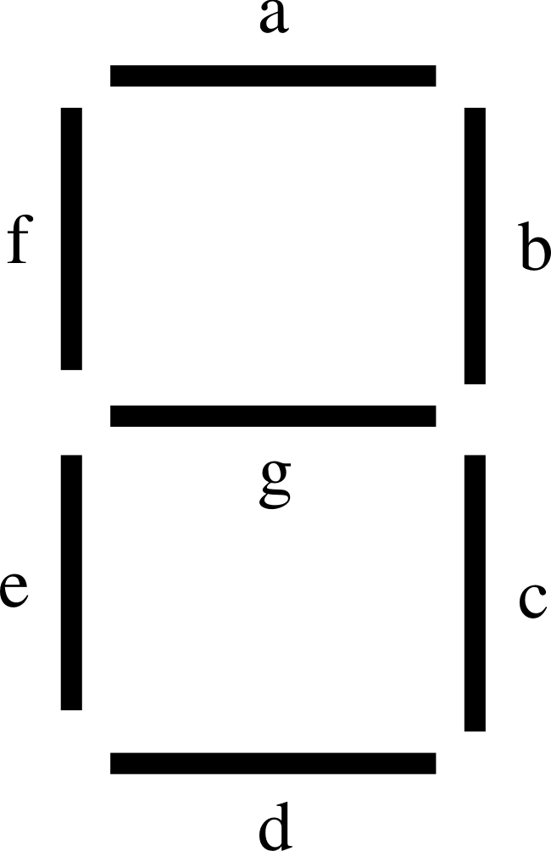
Figure.1 Seven segment decoder orientation [1]

Seven segment displays as explained in the lab manual are “constructed from LED wired together. This is referred to as a common anode or a common cathode seven segment LED.”[2] For this lab we will be using the common anode display. As described in the lab manual, “ common anode displays are called active low since the common anode is tied to the positive power supply (5v), each segment cathode tied to a segment driver through a current limiting resister, and a logic low output turns the segment on. Assuming a positive logic convention this means that a logic ‘0’ turns the segment on.”[3]

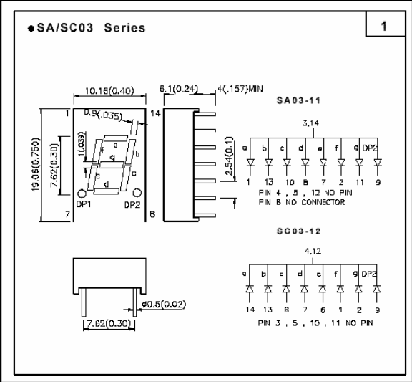
Figure 2 SA03-12HDB7 7 segment display [4]
Hex # | A | B | C | D |  | a | b | c | d | e | F | g
0 | 0 | 0 | 0 | 0 |  | 0 | 0 | 0 | 0 | 0 | 0 | 1
1 | 0 | 0 | 0 | 1 |  | 1 | 0 | 0 | 1 | 1 | 1 | 1
2 | 0 | 0 | 1 | 0 |  | 0 | 0 | 1 | 0 | 0 | 1 | 0
3 | 0 | 0 | 1 | 1 |  | 0 | 0 | 0 | 0 | 1 | 1 | 0
4 | 0 | 1 | 0 | 0 |  | 1 | 0 | 0 | 1 | 1 | 0 | 0
5 | 0 | 1 | 0 | 1 |  | 0 | 1 | 0 | 0 | 1 | 0 | 0
6 | 0 | 1 | 1 | 0 |  | 0 | 1 | 0 | 0 | 0 | 0 | 0
7 | 0 | 1 | 1 | 1 |  | 0 | 0 | 0 | 1 | 1 | 1 | 1
8 | 1 | 0 | 0 | 0 |  | 0 | 0 | 0 | 0 | 0 | 0 | 0
9 | 1 | 0 | 0 | 1 |  | 0 | 0 | 0 | 1 | 1 | 0 | 0
A | 1 | 0 | 1 | 0 |  | 0 | 0 | 0 | 1 | 0 | 0 | 0
B | 1 | 0 | 1 | 1 |  | 1 | 1 | 0 | 0 | 0 | 0 | 0
C | 1 | 1 | 0 | 0 |  | 0 | 1 | 1 | 0 | 0 | 0 | 1
D | 1 | 1 | 0 | 1 |  | 1 | 0 | 0 | 0 | 0 | 1 | 0
E | 1 | 1 | 1 | 0 |  | 0 | 1 | 1 | 0 | 0 | 0 | 0
F | 1 | 1 | 1 | 1 |  | 0 | 1 | 1 | 1 | 0 | 0 | 0
Table 1 Truth Table

The Karnaugh maps for the 7 Segment display are shown as Figure 3.
 | YZ
WX |  | 00 | 01 | 11 | 10
 | 00 | 0 | 0 | 0 | 0
wx | 01 | 0 | 1 | 0 | 1
 | 11 | 1 | 0 | 1 | 1
 | 10 | 0 | 0 | 1 | 0
 |  |  | B
 | YZ
WX |  | 00 | 01 | 11 | 10
 | 00 | 0 | 1 | 0 | 0
 | 01 | 1 | 0 | 0 | 0
 | 11 | 0 | 1 | 0 | 0
 | 10 | 0 | 0 | 1 | 0
 |  |  | A
Figure 3A Figure 3B
 | YZ
WX |  | 00 | 01 | 11 | 10
 | 00 | 0 | 1 | 0 | 0
 | 01 | 1 | 0 | 1 | 0
 | 11 | 0 | 0 | 1 | 0
 | 10 | 0 | 0 | 0 | 1
 |  |  | D
 | YZ
WX |  | 00 | 01 | 11 | 10
 | 00 | 0 | 0 | 0 | 1
 | 01 | 0 | 0 | 0 | 0
 | 11 | 1 | 0 | 1 | 1
 | 10 | 0 | 0 | 0 | 0
 |  |  | C

Figure 3C Figure 3D

 | YZ
WX |  | 00 | 01 | 11 | 10
 | 00 | 0 | 1 | 1 | 0
 | 01 | 1 | 1 | 1 | 0
 | 11 | 0 | 0 | 0 | 0
 | 10 | 0 | 1 | 0 | 0
 |  |  | E
Figure 3E
 | YZ
WX |  | 00 | 01 | 11 | 10
 | 00 | 0 | 1 | 1 | 1
 | 01 | 0 | 0 | 1 | 0
 | 11 | 0 | 1 | 0 | 0
 | 10 | 0 | 0 | 0 | 0
 |  |  | F
Figure 3F
 | YZ
WX |  | 00 | 01 | 11 | 10
 | 00 | 1 | 1 | 0 | 0
 | 01 | 0 | 0 | 1 | 0
 | 11 | 1 | 0 | 0 | 0
 | 10 | 0 | 0 | 0 | 0
 |  |  | G
Figure 3G

The minimum pos expressions are:

a = (A + B + C + D)(A + B + C + D)(A + B + C + D)(A + B + C + D)

b = (A + B + C + D)(A + B + D)(A + C + D)(B + C + D)
c = (A + B + C + D)(A + B + D)(A + B + C)
d = (A + B + C + D)(A + B + C + D)(B + C + D)(B + C + D)
e = (A + B + C)(A + D)(B + C + D)
f = (A + B + C + D)(A + B + C)(A + B + D)(A + C + D)
g = (A + B + C)(A + B + C + D)(A + B + C + D)

The minimum sop expressions are:
a = AC(B XOR D) + AD(B XOR C)

b = BCD + ABD + ACD + ABCD

c = ABC + ABD +ABCD
d = ABCD + ABCD+BCD + BCD
e = A(D + BC) + BCD
f = AB(D + C) + D(AC + ABC)

g = A(BC + BCD) + ABCD

Procedure, Results, and Analysis:
Log onto Unix workstation. Open terminal window. Type mkdir lab7[enter]. Then type cd lab7[enter], sul[enter], and swd[enter]. You should already have truth tables and k-maps like the ones above prepared. Type DA[enter]. This opens design architect. Then you construct the schematic in Appendix A in design architect. Once you have it built, test it and if there are not any errors save it as lab7. Now create a viewpoint by typing pld_dve –s lab7 spartan[enter] into the terminal window. Now open quicksim by typing quicksim lab7[enter]. Select all the input and output ports. Then make a list and a simulation. Now select input 8 and then pattern generator. Make the pattern happen 1 time for 800nsec. Repeat for inputs 1,2 and 4. Make input 4 happen 2 times for 400nsec, input 2 happen 4 times for 200nsec, and input 1 happen 8 times for 100nsec. Run the simulation for 1600nsec and verify that it works properly. Save the results and print them. Now we are going to create a symbol. You’ll want to reopen design architect and the lab7 schematic if you closed it. Then click on miscellaneous>generate symbol. Make sure the following are checked before accepting. Replace existing, sort pins, and check with defaults. Open a new sheet in design architect and name it something other than lab7. Then click add/route > choose symbol. Make the schematic in appendix B. Check for errors and save. Then type xmake “new filename” Spartan xcs05-3-pc84[enter] into the terminal window. Then type cd “new filename”[enter], cd xproj[enter], and print% lpr “newfilname”.dly “newfilename”.par[enter]. Now construct the circuit in appendix C using a breadboard, some resistors (330Ω and 470Ω), dipswitch, FPGA, and seven segment display. Log onto a PC. Ftp the bit file onto the pc by first creating a directory on the c drive. Then use the run command and type CMC. Then ftp Mhz.ece.umr.edu. Login with your password and username for EE. Navigate to the Unix directory that you saved the bit file in. To get the bit file type get lab7.bit C:/username/lab7_new.bit[enter], bye[enter], and quit[enter]. Now download the lab7_new.bit file onto the FPGA. Verify the file by using the dip switch and LED display. Test circuit the propagation delay of your circuit by hooking up a 4 bit pattern generator “Patgen”. Record your results.
Conclusions:
The FPGA takes up considerably less room than all the gates that it would have taken to make this circuit and ours worked as it was designed to with no unexpected outputs. It took 4 configurable logic blocks, which were comprised of a total of 32 primitive gates to make this design. There were also 4 primitive output gates in this design. After measuring the propagation delay with patgen; it was found that a 6.69ns delay from dipsw4 to pin 12 was the worst delay. The 6.69ns was twice the delay of the next worst case.

Appendix A Schematic Design for a Seven Segment Decoder

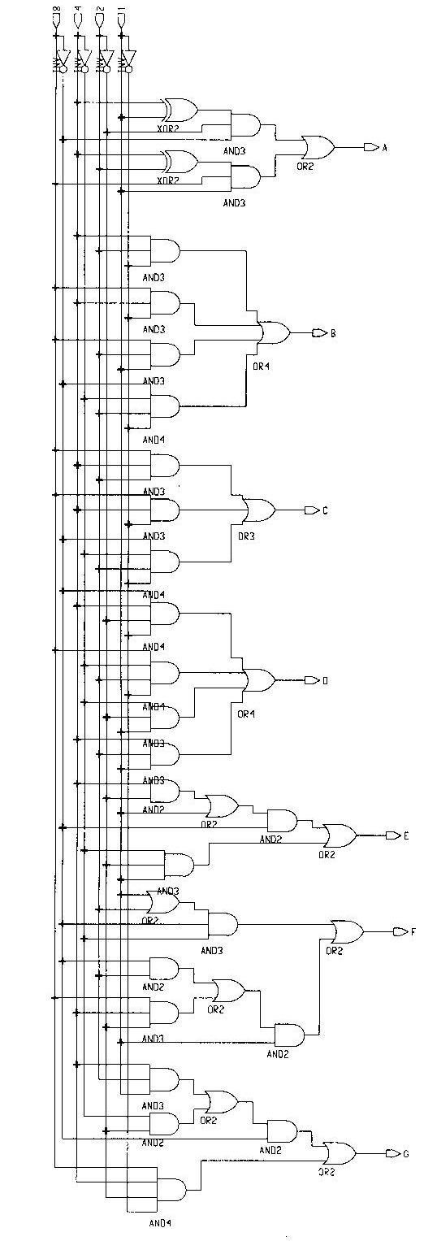
Schematic Design for Seven Segment Decoder
Appendix B Top Level sheet for SSD Design

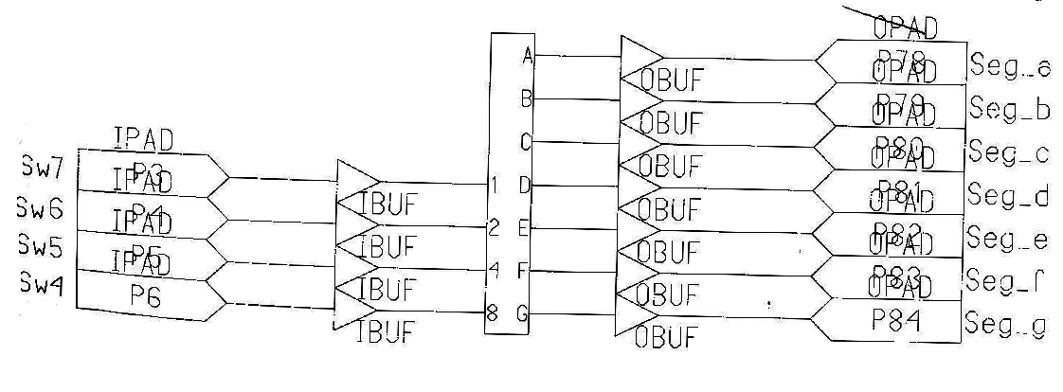
Layout of Top level Sheet for SSD Design

Appendix C Circuit for Seven Segment Decoder

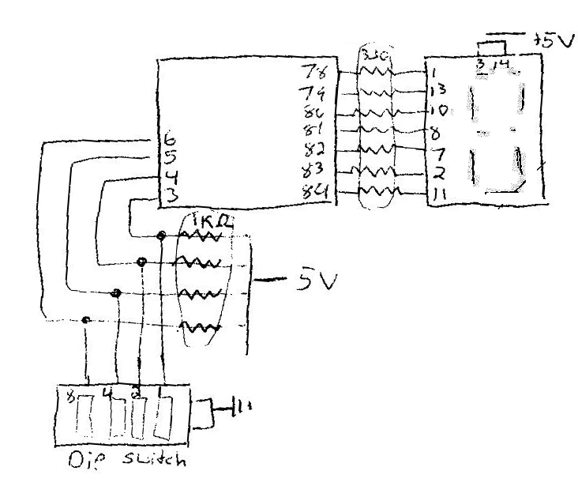
Circuit for Seven Segment Decoder

References:

- Colorado State, “7 Segment Decoder gif”, http://www.engr.colostate.edu/~dga/mechatronics/figures/6-34.gif, 1 page
- UMR Electrical and Computer Engineering Department, “Lab Manual for Computer engineering 112”, Spring 2006, 1
- UMR Electrical and Computer Engineering Department, “Lab Manual for Computer Engineering 112”, Spring 2006, 1
- UMR Electrical and Computer Engineering Department, “Lab Manual for Computer Engineering 112”, Spring 2006, 1

